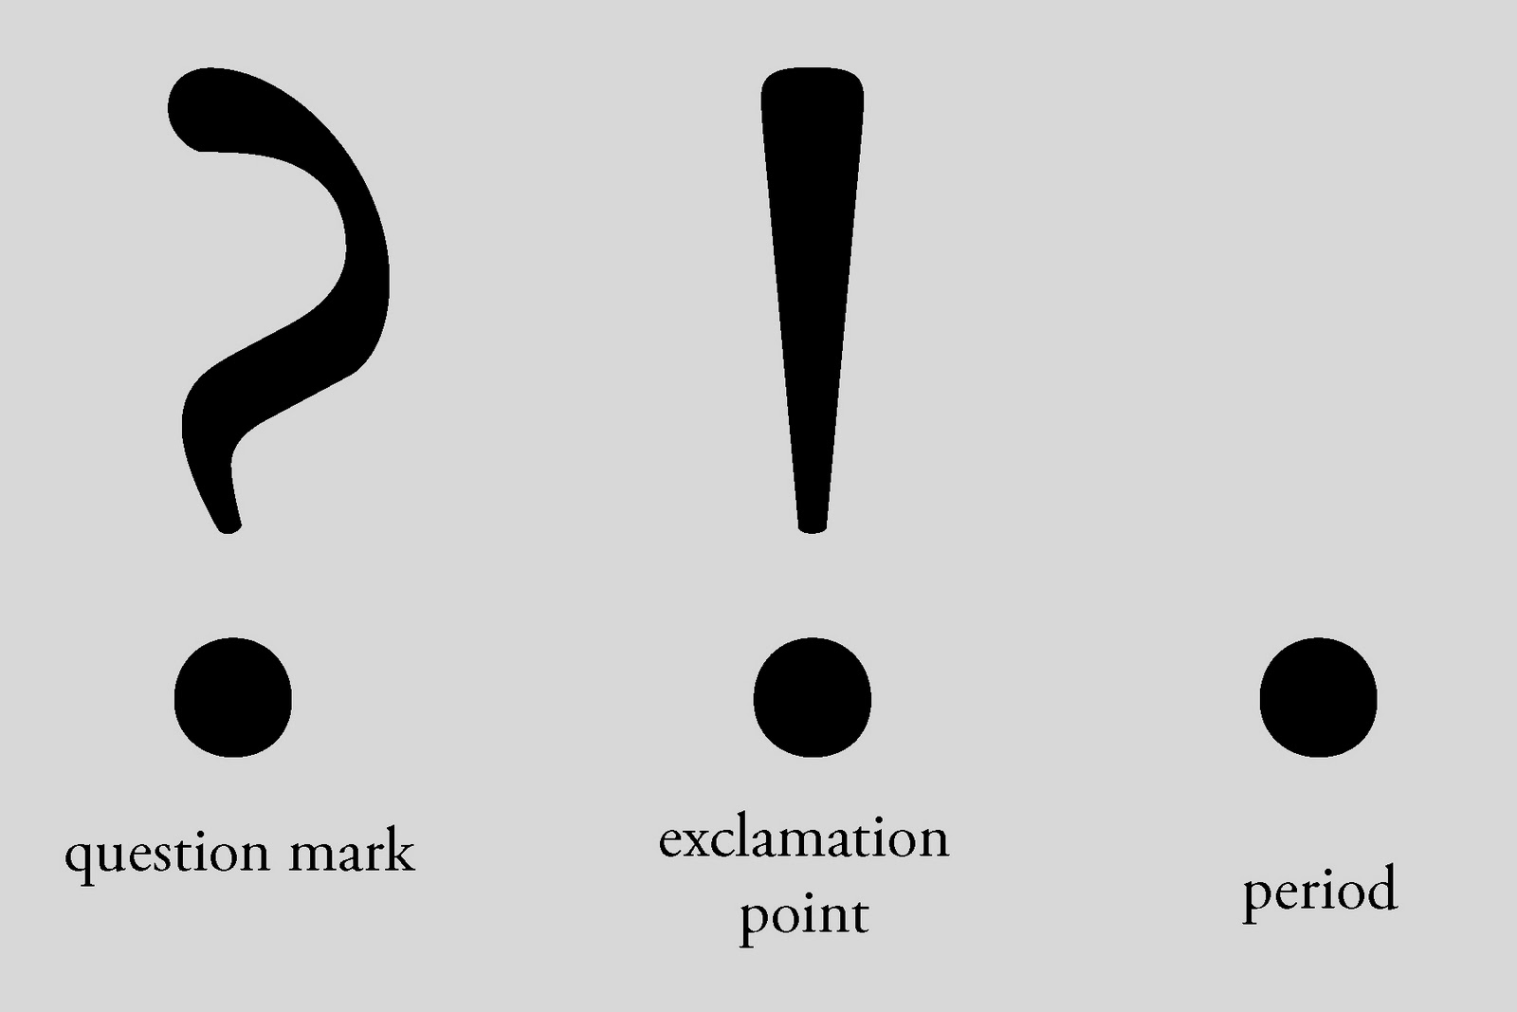

Warm-up: Punctuation Practice

End each sentence with the correct punctuation. Fill in the blanks below with a period, question mark, or exclamation point.

1. I’m from Canada__
2. What’s your name__
3. Congratulations__
4. Our English class starts at 9:00am__
5. Do you like dogs__
6. The elephant is my favorite animal__
7. I’m forty years old__
8. Oh no_
9. I like Hawaiian pizza_
10. Hurry_

