Dialogue 1: Practice with a friend or family member or use my audio to practice.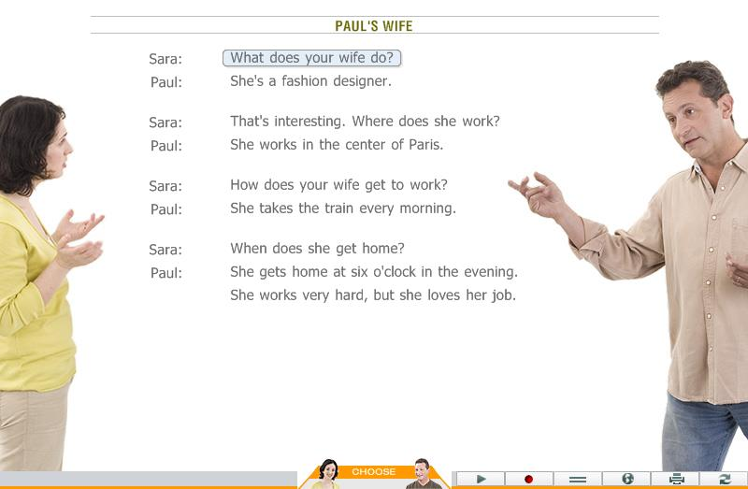

Dialogue 2